**Practical No 4**

1. Drag and drop a calendar control, image button and textbox on a web form. Use an image of calendar as an image for the button. On the click of the image button toggle the visibility of the calendar. On selecting a date in the calendar the respective date should be seen in the TextBox control. Show 11 ways to display date and time. Take care to not let the user select the weekends and dates of other month.

**.aspx**

<%@ Page Language="C#" AutoEventWireup="true" CodeBehind="WebForm1.aspx.cs" Inherits="WebApplication8.WebForm1" %>

<!DOCTYPE html PUBLIC "-//W3C//DTD XHTML 1.0 Transitional//EN" "http://www.w3.org/TR/xhtml1/DTD/xhtml1-transitional.dtd">

<html xmlns="http://www.w3.org/1999/xhtml">

<head runat="server">

<title></title>

</head>

<body>

<form id="form1" runat="server">

<div>

<asp:TextBox ID="TextBox1" runat="server" Width="115px"></asp:TextBox>

<asp:ImageButton ID="ImageButton1" runat="server"

ImageUrl="~/images/calender.png" onclick="ImageButton1_Click" />

<asp:Calendar ID="Calendar1" runat="server" ondayrender="Calendar1_DayRender"

onselectionchanged="Calendar1_SelectionChanged"></asp:Calendar>

</div>

</form>

</body>

</html>

**.cs**

using System;

using System.Collections.Generic;

using System.Linq;

using System.Web;

using System.Web.UI;

using System.Web.UI.WebControls;

namespace WebApplication8

{

public partial class WebForm1 : System.Web.UI.Page

{

protected void Page_Load(object sender, EventArgs e)

{

}

protected void Calendar1_SelectionChanged(object sender, EventArgs e)

{

TextBox1.Text = Calendar1.SelectedDate.ToShortDateString();

Calendar1.Visible = false;

//Date Conversion methods

+

}

protected void ImageButton1_Click(object sender, ImageClickEventArgs e)

{ TextBox1.Text = Calendar1.SelectedDate.ToShortDateString();

Calendar1.Visible = false;

//Date Conversion methods

Response.Write("ToString() - " + DateTime.Now.ToString() + "<br/>");

a Response.Write("ToLongDateString() - " + DateTime.Now.ToLongDateString() + "<br/>");

Response.Write("ToShortDateString() - " + DateTime.Now.ToShortDateString() + "<br/>");

Response.Write("ToLongTimeString() - " + DateTime.Now.ToLongTimeString() + "<br/>");

Response.Write("ToShortTimeString() - " + DateTime.Now.ToShortTimeString() + "<br/>");

// DateTime format strings

Response.Write("d - " + DateTime.Now.ToString("d") + "<br/>");

Response.Write("D - " + DateTime.Now.ToString("D") + "<br/>");

Response.Write("dd/MM/yyyy - " + DateTime.Now.ToString("dd/MM/yyyy") + "<br/>");

Response.Write("dd/MMMM/yyyy - " + DateTime.Now.ToString("dd/MMMM/yyyy") + "<br/>");

Response.Write("dd/MMMM/yy - " + DateTime.Now.ToString("dd/MMMM/yy") + "<br/>");

Response.Write("MM/dd/yy - " + DateTime.Now.ToString("MM/dd/yy") + "<br/>");

}

protected void Calendar1_DayRender(object sender, DayRenderEventArgs e)

{

if (e.Day.IsWeekend || e.Day.IsOtherMonth)

{

e.Day.IsSelectable = false;

e.Cell.BackColor = System.Drawing.Color.LightGray;

}

}

}

}

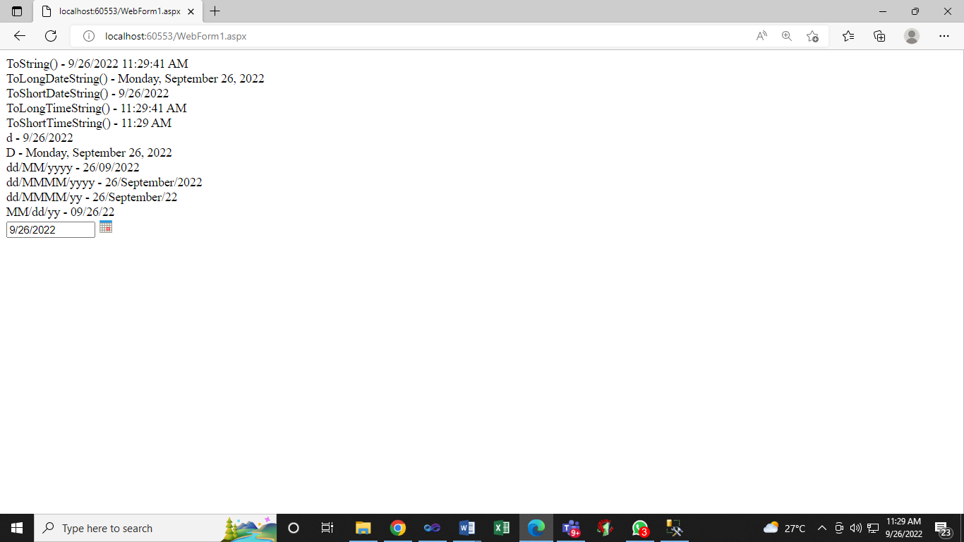

1. Drag and drop a calendar demonstrate the use of at least 5 properties, also on selecting a date show the date on the web page,take care to not let the user select the weekends and dates of other month, even dates to be seen as bold X in white color with red background, tooltip of even dates to be seen as “Booked” and of odd dates as “Available”, on changing the month a message **“Month changed from Sep to Oct”** should be seen on the web page.

**.aspx**

<%@ Page Language="C#" AutoEventWireup="true" CodeBehind="WebForm1.aspx.cs" Inherits="WebApplication8.WebForm1" %>

<!DOCTYPE html PUBLIC "-//W3C//DTD XHTML 1.0 Transitional//EN" "http://www.w3.org/TR/xhtml1/DTD/xhtml1-transitional.dtd">

<html xmlns="http://www.w3.org/1999/xhtml">

<head runat="server">

<title></title>

</head>

<body>

<form id="form1" runat="server">

<div>

<asp:Calendar ID="Calendar1" runat="server" ondayrender="Calendar1_DayRender"

onselectionchanged="Calendar1_SelectionChanged"

onvisiblemonthchanged="Calendar1_VisibleMonthChanged"></asp:Calendar>

</div>

</form>

</body>

</html>

**.cs**

using System;

using System.Collections.Generic;

using System.Linq;

using System.Web;

using System.Web.UI;

using System.Web.UI.WebControls;

namespace WebApplication8

{

public partial class WebForm1 : System.Web.UI.Page

{

protected void Page_Load(object sender, EventArgs e)

{

}

protected void Calendar1_DayRender(object sender, DayRenderEventArgs e)

{

if (e.Day.IsWeekend || e.Day.IsOtherMonth)

{

e.Day.IsSelectable = false;

e.Cell.BackColor = System.Drawing.Color.LightGray;

}

if (!e.Day.IsOtherMonth && e.Day.Date.Day % 2 == 0)

{

e.Cell.Text = "x";

e.Cell.Font.Bold = true;

e.Cell.ForeColor = System.Drawing.Color.White;

e.Cell.BackColor = System.Drawing.Color.Red;

e.Cell.ToolTip = "Booked";

}

else

{

e.Cell.ToolTip = "Available";

}

}

protected void Calendar1_SelectionChanged(object sender, EventArgs e)

{

foreach (DateTime selectedDate in Calendar1.SelectedDates)

{

Response.Write(selectedDate.ToShortDateString() + "<br/>");

}

}

protected void Calendar1_VisibleMonthChanged(object sender, MonthChangedEventArgs e)

{

Response.Write("Month changed from ");

Response.Write(GetMonthName(e.PreviousDate.Month));

Response.Write(" to ");

Response.Write(GetMonthName(e.NewDate.Month));

}

private string GetMonthName(int MonthNumber)

{

switch (MonthNumber)

{

case 1:

return "Jan";

case 2:

return "Feb";

case 3:

return "Mar";

case 4:

return "Apr";

case 5:

return "May";

case 6:

return "Jun";

case 7:

return "Jul";

case 8:

return "Aug";

case 9:

return "Sep";

case 10:

return "Oct";

case 11:

return "Nov";

case 12:

return "Dec";

default:

return "Invalid Month";

}

}

}

}

**Output**

